The “Good News” of St. Paul United Church of Christ
January 2019
The Mission of St. Paul UCC, a congregation united in Jesus Christ, is to share the gospel of Christ and to share his love for us with others in our community. We will work to bring others to the knowledge of Jesus by showing that we are a caring and welcoming congregation.

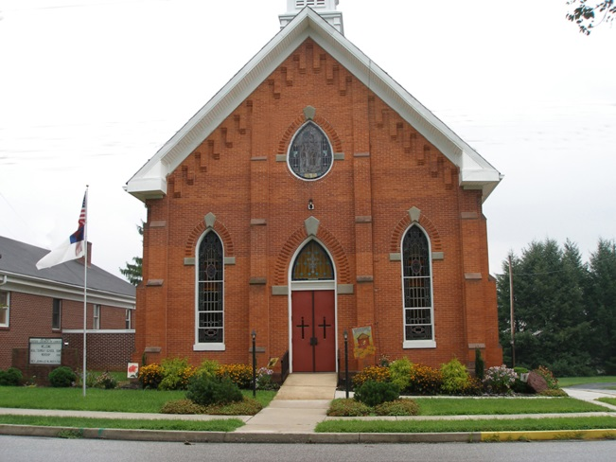
161 S. Main St.
Shrewsbury, PA 17361
Phone: 717-235-7003
Email: st.paulucc@verizon.net
www.saintpaulucc.com
Pastor: The Rev. Dr. Martha H. Boyer

Handicap Accessible
Staffed Nursery Available

Worship Service

Worship 10:15 am
Adult Church School 9:00 am
A MESSAGE FROM PASTOR MARTHA
It's a New Year, 2019. A new year always makes me look forward to freshness and new possibilities. It is an awesome adventure when you follow Christ, wherever he leads you.

As I write this note, it is not yet January. In fact it is November 20, right before we celebrate Thanksgiving. Yesterday, our beloved dog of 14 years, Shakespeare entered into the heavenly courts, where dogs play ball every day unto eternity.

A little girl in Macungie, asked me once whether her cat who had died went to heaven. Without hesitation I answered definitely. God looked at all of his creation and every little creatures great and small and proclaimed how good they were. This is recorded in Genesis. Later on in the chapter, Noah herded two of each animal into the ark that God had commanded him to build. God cares for our loving furry companions as much as he cares for the little sparrows.

I have had numerous friends in the community, at church and on Facebook, who supported us with their prayers. For this, I am deeply grateful. I can feel the loving support and now our minds are filled with wonderful memories of Shakespeare who was truly a part of our family these past 14 years.

I know that the new year will bring us many new blessings and I want all of my church friends to know how blessed we were to have a dog, Cairn Terrier, named Shakespeare. May you all be truly blessed in the New Year 2019!!!

NO MATTER WHO YOU ARE…OR WHERE YOU ARE ON LIFE’S JOURNEY…YOU ARE WELCOME AT THE UNITED CHURCH OF CHRIST.

The Good News of St. Paul – Activities January 2019

ITEMS FOR THIS MONTH: SOUTHERN YORK COUNTY PANTRY is an independent, all volunteer operation that exists because of the generosity of many individuals and businesses, local and national, as well as many area churches and community groups. The pantry strives to serve residents in south- central York County with emergency food, and/or energy assistance. It serves regardless of race, age, or creed. Volunteers do not evangelize. No government assistance or funding is received. The first Sunday of every month has been designated for us to bring our Pantry items. Items for January: spaghetti sauce, pancake mix, pancake syrup, Spam/Treet

(Please place items in the bin in the narthex.) Brown Paper grocery bags are really needed! Monetary donations are always appreciated! Give so others might LIVE! See Sandy or Pastor Martha for more information.

ALTAR FLOWER SPONSORS
Sponsoring the Altar Flowers is a wonderful way to honor or memorialize a loved one. If you would like to sponsor Altar Flowers through the church, please contact Janice Fritz (717.235.1235).

BULLETIN SPONSORSHIP costs $7/week. This makes a nice way to memorialize or honor a loved one and also helps out St. Paul. Please make checks payable to: St. Paul UCC & given to Sandy Schroeder.

2019 BULLETIN SPONSORS & GREETER LIST IS AVAILABLE Volunteers are needed for monthly greeters. Please see the list in the narthex and SIGN UP!

ADULT SUNDAY SCHOOL CLASS “God’s Promises for Your Every Need” continues. Please join us at 9:00am for our lively discussions. For more information, contact Pastor Martha Boyer at 717 858-2991.

FELLOWSHIP GATHERING
Join us on Sunday mornings for lots of good conversation, tasty treats, a cup of coffee, tea, or juice and assorted refreshments before church at 9:45-10:00 and after service. Come and get to know your church members. Each member is encouraged to host the Gathering. A sign up sheet is available on the church bulletin board or let Nancy Seim know when you are able to act as host. Thanks to all those folks who hosted in 2018!!

WORLD VISION CHILDREN is a Christian relief, development and advocacy organization dedicated to working with children, families and communities to overcome poverty and injustice. In 2016, 85% of World Vision's total operating expenses were used for programs that benefit children, families, and communities in need.

St. Paul Church has been supporting three children from World Vision for at least the past 10 years. We would like to continue so we need your help or we may have to cut back to only two children. So at $90/mo., if 20 people would pledge to give $4.50/mo. or 15 people pledge $6/mo or 10 people would pledge $9/mo. we could continue to support three children. This would be over and above the amount you currently give in your monthly offering. Please pray on this and when the signup sheet is circulated, please give what you are able. Please see Sandy Schroeder with questions.

MARK YOUR CALENDARS

CONSISTORY MEETING will be held on Monday, January 14 at 7P. All members are encouraged to attend.

LUNCH BUNCH – meets at Cracker Barrel on the third Monday of every month at 12 noon. This month is January 15. Everyone is invited to join with us.

JOIN US ON SUNDAY, JANUARY 6TH AS WE
CELEBRATE HOLY COMMUNION!

The Good News St. Paul—scriptures and readers January 2019

January 6th Epiphany Holy Communion

Old Testament Lesson: Isaiah 60:1-6,
Epistle Lesson: Ephesians 3:1-12
Gospel Lesson: Matt 2:1-12

Sermon: Great is Your Faithfulness

Reader: Jan

January 13th The Baptism of Christ

Old Testament Lesson: Isaiah 43:1-7
A New Testament Lesson: Acts 8:14-17
Gospel Lesson: Luke 3:15-17, 21-22

Sermon: Biblical Serendipity

Reader: Nancy

January 20th Epiphany 3

Old Testament Lesson: Isaiah 62:1-5
Epistle Lesson: 1 Corinthians 12:1-11
Gospel Lesson: John 2:1-11

Sermon: Extravagant Signs

Reader: Tom

January 27th Epiphany 4

Old Testament Lesson: Psalm 19
Epistle Lesson: 1 Corinthians 12:13-31a,
Gospel Lesson: Luke 4:14-21

Sermon: Kindle Wisdom

Reader: Andrew

SUNDAY | MONDAY | TUESDAY | WEDNESDAY | THURSDAY | FRIDAY | SATURDAY
 |  | 1 New Year’s Day | 2  12noon NA mtg | 3 | 4 | 5
6 Epiphany  9:00 AM Adult Sunday School  10:15 AM Communion | 7  7-8:15P NA [FH] | 8  8A-5P WIC | 9  12noon NA mtg | 10 | 11 | 12
13 The Baptism of Christ  9:00 AM Adult Sunday School  10:15 AM Worship | 14  7P Consistory  7-8:15P NA [FH] | 15 | 16  12noon NA mtg | 17  Week of Prayer for Christian Unity  (Jan. 18-25) | 18 | 19
20 Epiphany 2  9:00 AM Adult Sunday School  10:15 AM Worship | 21  12P Lunch @  Cracker  Barrel  7-8:15P NA [FH] | 22  Pastor Martha @ Pastors’ Convocation  (Jan. 22—24) | 23  12noon NA mtg | 24 | 25 | 26
27 Epiphany 3  9:00 AM Adult Sunday School  10:15 AM Worship | 28  7-8:15P NA [FH] | 29 | 30  12noon NA mtg | 31

The Good News St. Paul – Calendar January 2019
The Good News St. Paul – milestones January 2019

HAPPY BIRTHDAY

Betty Hildebrand January 03
Jason Zeigler January 03
Barbara Rezmer January 23

(To the best of our abilities, these listings are correct. If these are not correct or are incomplete, please notify the secretary. Thank you)

NOTE RECEIVED VIA EMAIL TO ST. PAUL CHURCH:
On October 28th we celebrated our daughter, Scarlett Pearl Perkins, birthday at St Paul UCC and what a blast it was! Cory and I would like to thank you from the bottom of our hearts for allowing us to use the space for our little girl. It was the place that Cory and I united ourselves in front of our friends, family and the Lord and it meant so much that we celebrated our little girl’s big day at the same place! Thank you so much and have a blessed day! Kiersten Perkins

The prayer of St. Francis
Lord, make me an instrument of your peace,
Where there is hatred, let me sow love;
where there is injury, pardon;
where there is doubt, faith;
where there is despair, hope;
where there is darkness, light;
where there is sadness, joy;

O Divine Master, grant that I may not so much seek to be consoled as to console; to be understood as to understand;
to be loved as to love.

For it is in giving that we receive;
it is in pardoning that we are pardoned;
and it is in dying that we are born to eternal life.

St. Francis was born at Assisi in 1182. After a care free youth, he turned his back on inherited wealth and committed himself to God. Like many early saints, he lived a very simple life of poverty, and in so doing, gained a reputation of being the friend of animals. He established the rule of St Francis, which exists today as the Order of St. Francis, or the Franciscans. He died in 1226, aged 44.

May we find peace and joy in this new year.
To you and all, a happy, healthy 2019

The Good News of St. Paul – prayer list January 2019
Members Homebound

DOT EDSALL
APT 313
100 LUTHER RD
SHREWSBURY PA 17361
DORIS HEYNE
AUTUMN HOUSE – RM #B15
2618 E MARKET ST

YORK PA 17402

BETTY HILDEBRAND
5699 SWAMP RD
FELTON PA 17322
CORDELIA WOLFE
9415 YELLOW CHURCH RD
SEVEN VALLEYS PA 17360

ST. PAUL UCC MEMBERS / HEALTH CONCERNS:

DAVID BOYER, MARK CRAMER, DOT EDSALL, JANICE FRITZ, DORIS HEYNE, BETTY HILDEBRAND, NANCY LEBER, RICHARD LEBER, BRENT MORTHLAND, DEB MORTHLAND, BOB & JANE SCHMIEDT, NICOLE SMITH-ZEIGLER, ALLAN SOTO, RICHARD & DORIS WINEMILLER

FRIENDS OF ST. PAUL

SARA KERCHNER | JUDY FAILING & FAMILY | MARTY SAUBEL
BETTY AREY | BOB TYRRELL | NOLA SMITH
BOB DENNEY | KELLY KASHNER | CASEY TYRRELL
RAY STIFFLER | SHARON BLEVINS | TAVEN
SANDY HUNT | DONALD GEETING | MICHAEL BLESSING
LOGAN S. | HENRY WHERLEY | JESSIE WRIGHT
BONNIE PRICE | SANDY & KIM STERNER | ISABELLA ROSE KUPISCH
KENNY AREY | KIM MARKLE | TESS SPRADIN
CHRIS GOODLING | PAUL ENGEL | MARY ALICE BUTKOFSKY
DAWN ULRICH | SHIRLEY RUTH | DAN & TRACY RUSSELL
DENNY, DEBBIE & DERRICK | KEVIN KREPPS

Children we support thru World Vision: Rosabelle Jean Barhouch,
Juana Ines Hernandez Ixtamer and Vazgen Tovmasyan

BLESS OUR TROOPS Lord, hold our troops in your loving hands. Protect them as they protect us. Bless them and their families for the selfless acts they perform for us in our time of need. We ask this in the name of Jesus, our Lord and Savior. Amen.

PRESIDENT TRUMP, FEDERAL, STATE, CITY AND TOWN GOVERNMENTS

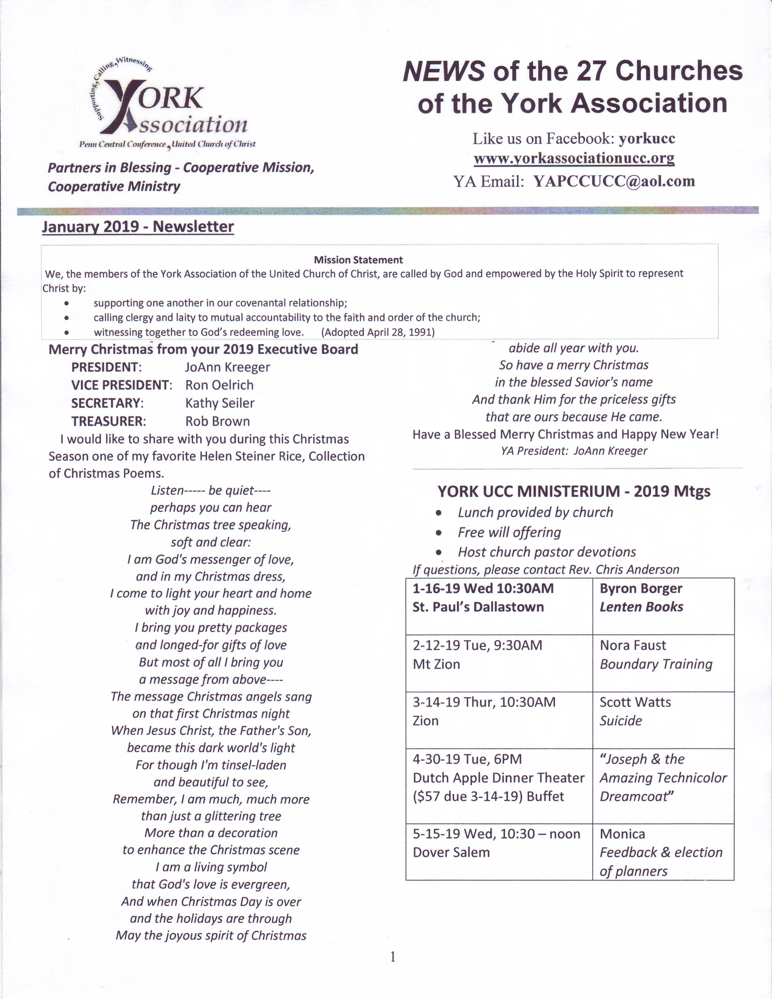

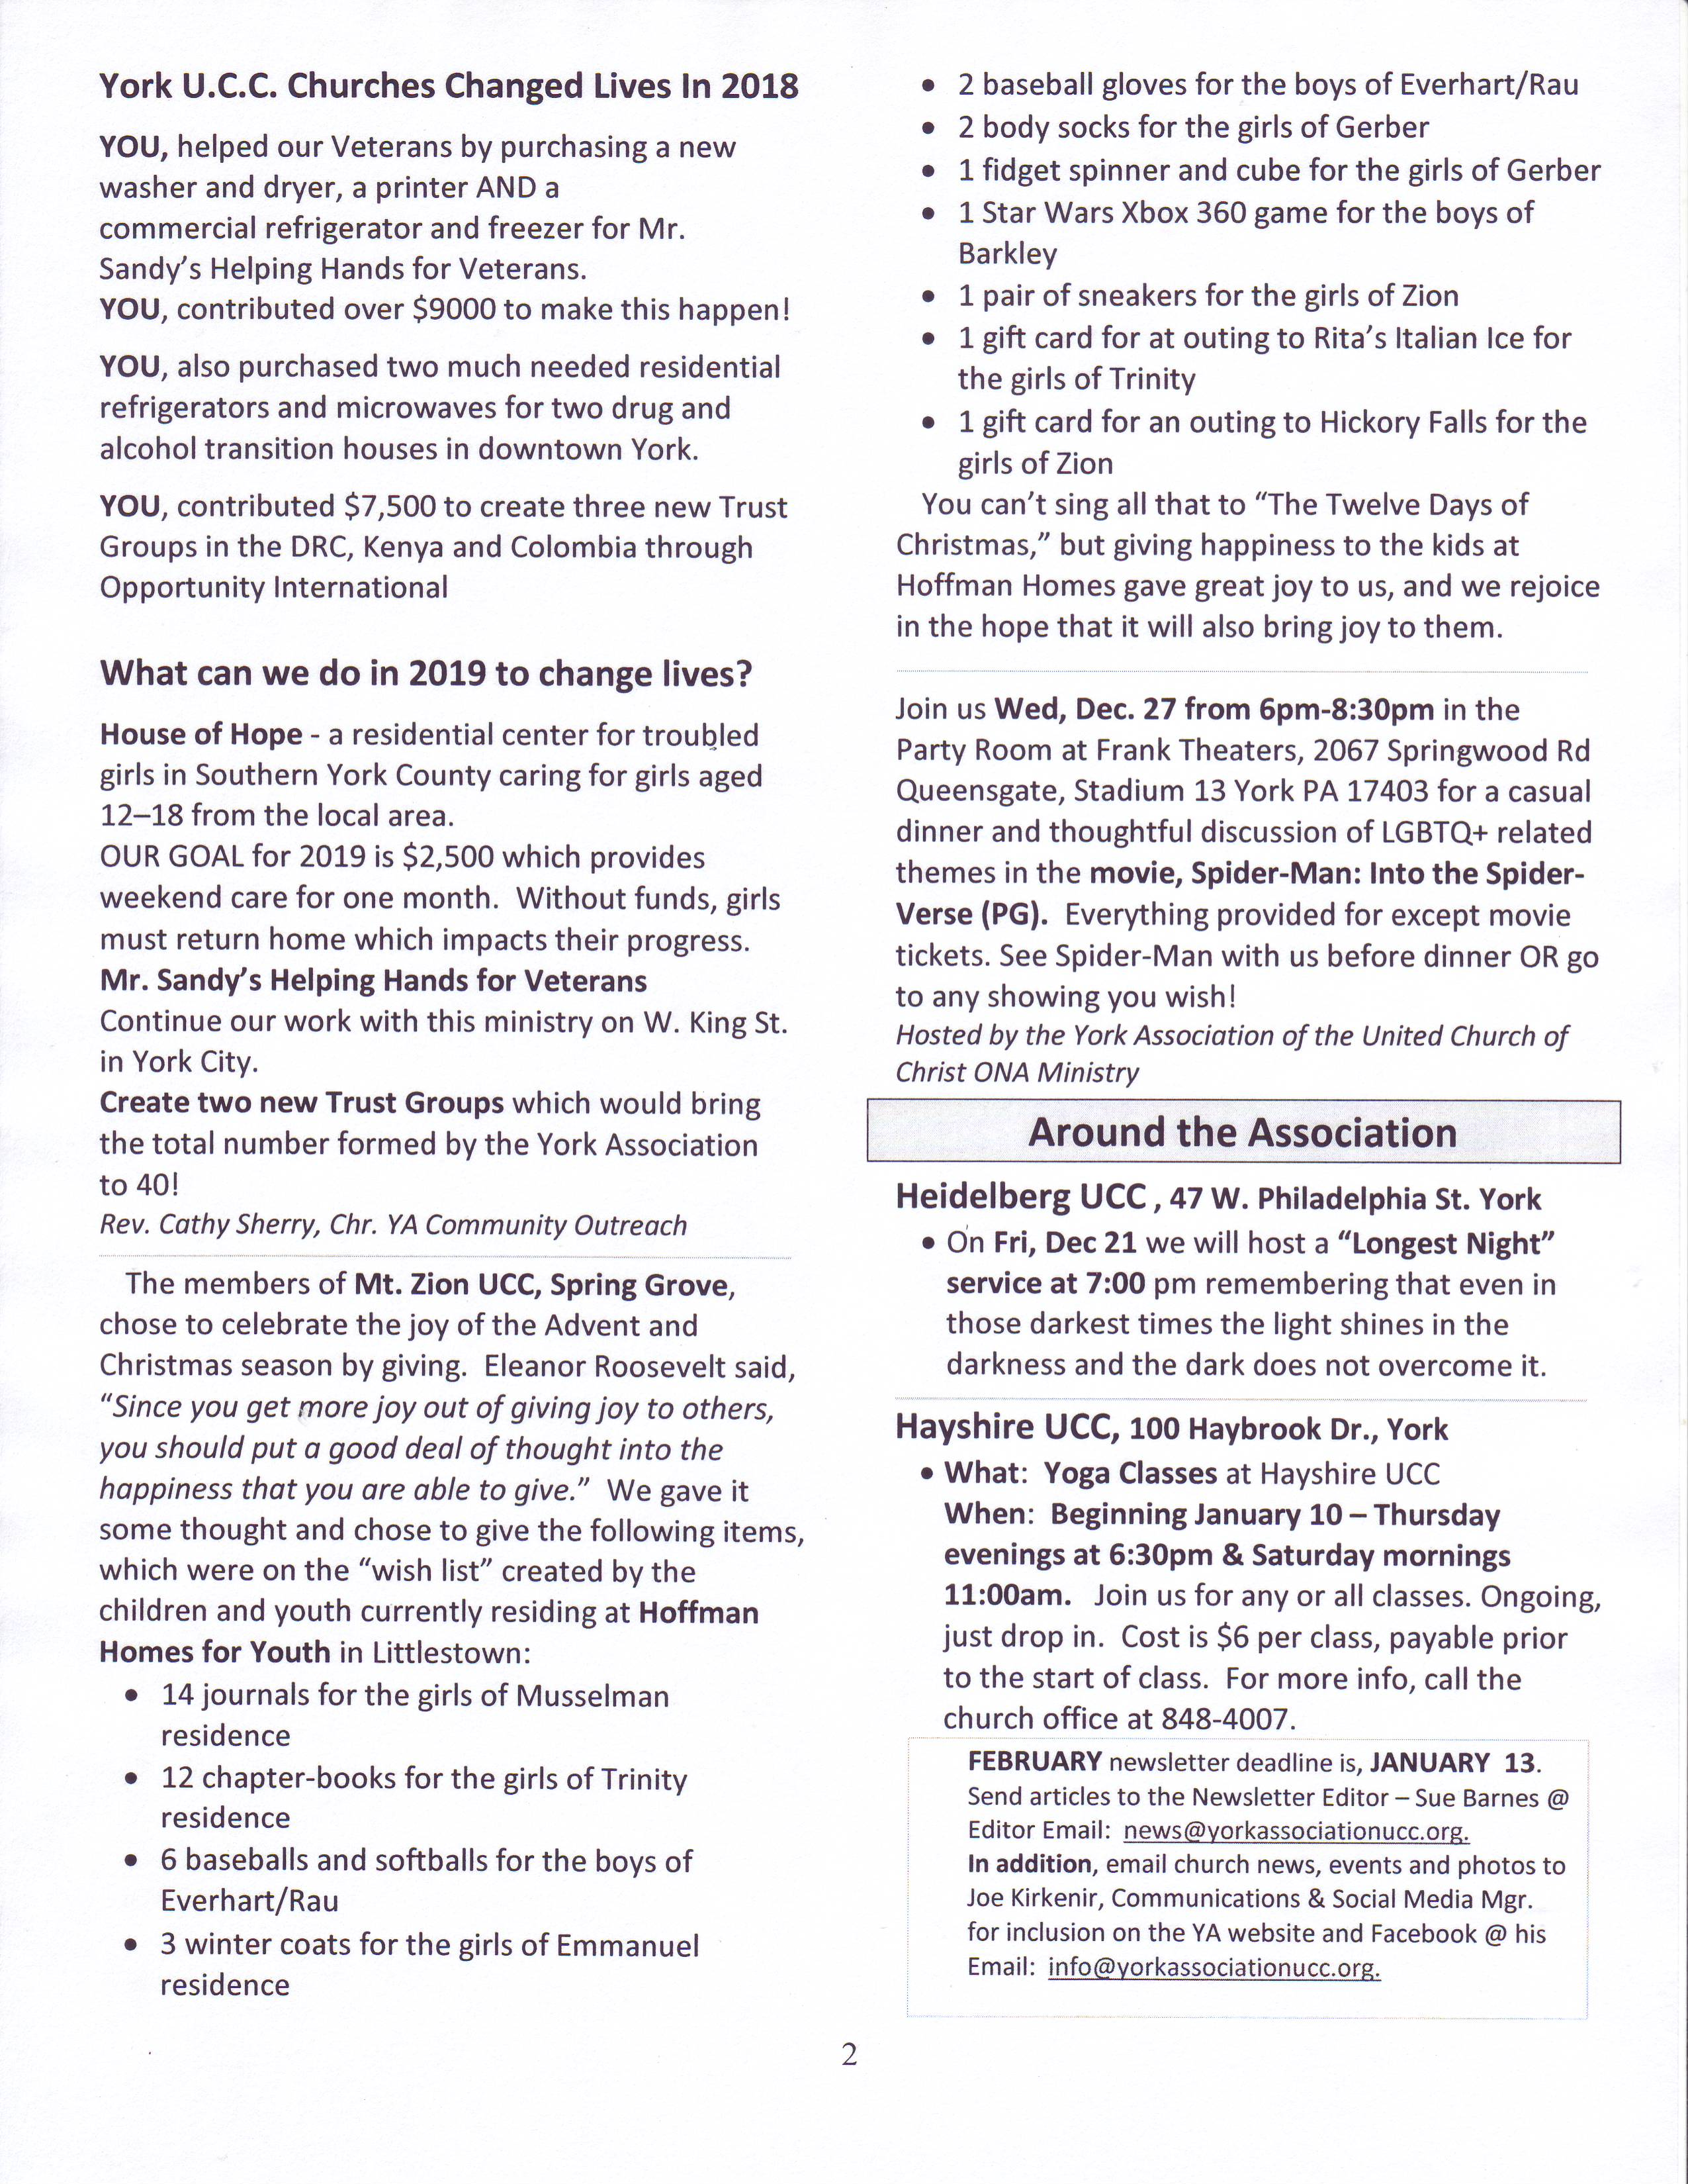

ASSISTING MINISTERS FEBRUARY
 | January 6 | January 13 | January 20 |  | January 27
FLOWER  SPONSOR(S) |  |  |  |  | .
READER | Jan | Nancy | Tom |  | Andrew
GREETER(S) | [Volunteer Needed]
BULLETIN  SPONSOR(S) | In loving memory of Grandma Sechrist, Rene & Harold Fritz  by Harold and Janice.
FELLOWSHIP

The Good News of St. Paul January / February 2019

ASSISTING MINISTERS FEBRUARY
 | February 3 | February 10 | February 17 |  | February 24

FLOWER

SPONSOR(S)
READER | Pastor Martha | Mark | Jan |  | Nancy
GREETER(S) | [Volunteer Needed]
BULLETIN  SPONSOR(S) | [sponsorship available]
FELLOWSHIP

TREASURER’S REPORT

Balance 11/01/2017 $3,884.11
Total Inflows 9,492.36
Total Outflows (-5,102.15)
Balance 11/30/2017: $8,274.43

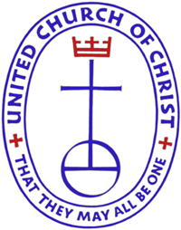
PASTOR
The Rev. Dr. Martha H. Boyer
140 Oak Ridge Dr., York PA 17402
Cell #717.858-2991
marthahboyer@hotmail.com

SECRETARY
Joan Kerchner
Office Phone: 717.235.7003
Hours: Tue., Wed., & Thu. 12:15p—3:15p

ORGANIST/CUSTODIAN
Loretta Daniels

TREASURER &FINANCIAL SECRETARY
Sandra Schroeder

CONSISTORY PRESIDENT
Jan Sechrist

WORSHIP — 10:15 AM
SUNDAY SCHOOL — 9:00 AM

Communion is celebrated the first Sunday of the month.

.

January
ST PAUL UNITED CHURCH OF CHRIST
161 S MAIN ST
SHREWSBURY PA 17361
st.paulucc@verizon.net

